Woodland Soccer Club  Affiliated with: US Club Soccer - C.Y.C.A.N - U.S.Y.A - U.S.S.F. & F.I.F.A  P.O. Box 1746 Woodland, California 95776 | 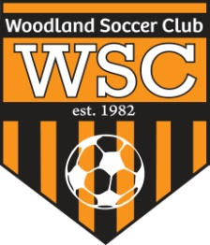

WSC Comp Meeting
Wednesday, January 25, 2012

CALL TO ORDER:

Meeting called to order at 6:30- 8:10pm by Robert Marin

ROLL CALL:
- Missing from meeting- Peter Holmes

APPROVAL OF MINUTES:
Motion to approve made by
Motion passed unanimously.
PRESIDENT REPORT:

COMMITTEE REPORT:
- Coach contract- Read over coaches contract. Coaches that miss a comp meeting will be deducted $50. Contract needs to be signed by coaches. Head coach needs coach/ref license. Incentive pay is only for tournaments won at the team’s current level.
- Tryouts- U15- U18 tryout dates will be changed.
- Teams practice times will be changed when the club is down to 1 ½ fields.
- Renew referee license at USSOCCER.INFO

FIRST VICE REPORT:
- Uniform samples brought in. Decision made to wait until fall uniforms come out to make a decision. Coaches should email Rich a list of any uniforms that are needed now.

HEAD COACH REPORT:

HEAD REFEREE REPORT:

TREASURER’S REPORT:

REGISTRAR’S REPORT:
- Registration- Need half of registration fee as a down payment by February 3. Remaining balance is due by March 1.

SECRETARY’S REPORT:

OLD BUSINESS: None

NEW BUSINESS:

GOOD OF GAME:

ADJOURNMENT:
Motion to adjourn by
Meeting adjourned at

NEXT MEETING:

