Woodland Soccer Club  Affiliated with: US Club Soccer - C.Y.C.A.N - U.S.Y.A - U.S.S.F. & F.I.F.A  P.O. Box 1746 Woodland, California 95776 | 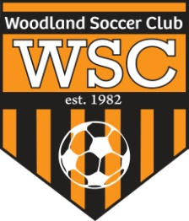

WSC Comp Meeting
June 28, 2012

CALL TO ORDER:

Meeting called to order at 7pm

ROLL CALL:

APPROVAL OF MINUTES:
Motion to approve made by
Motion passed unanimously.
PRESIDENT REPORT:
- If using guest players (outside of club) make sure to send form to US Soccer for insurance purposes.
- Reviewed coaches contract
- Sunshine Classic Tournament- 14-16 brackets have low registration. 1 team for U11 signed up
- Fields- Robert is trying to secure fields E, D and WHC

COMMITTEE REPORT:
- Still need coach for U10 Boys team

FIRST VICE REPORT:
- Uniforms- Custom Nike will take 60 days to get new and will expire in 2014. $132 for 2 sets of Nike Brasilia 3.
- Uniforms will be white with orange numbers and orange socks. Orange uniform with back numbers and black socks

HEAD COACH REPORT:

HEAD REFEREE REPORT:

TREASURER’S REPORT:

REGISTRAR’S REPORT:
- Deadline to sign up teams with Norcal is July 1st
- Need new pictures for fall. Do not need birth certificate for current players

SECRETARY’S REPORT:

OLD BUSINESS: None

NEW BUSINESS:

GOOD OF GAME:

ADJOURNMENT:
Motion to adjourn by
Meeting adjourned at

NEXT MEETING:

