Woodland Soccer Club  Affiliated with: US Club Soccer - C.Y.C.A.N - U.S.Y.A - U.S.S.F. & F.I.F.A  P.O. Box 1746 Woodland, California 95776 | 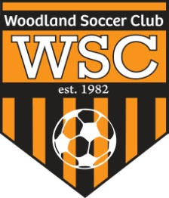

WSC Board Meeting
Wednesday, October 10, 2012

CALL TO ORDER:

Meeting called to order at 5:30pm

ROLL CALL:

APPROVAL OF MINUTES:
Motion to approve made by
Motion passed unanimously.
PRESIDENT REPORT:
- Ordering T-shirts for board, comp and rec coaches
- Thanksgiving tournament- 16 teams signed up. Will wait until the end of October to decide to continue w/ tournament or cancel
- Fields- Robert to discuss w/ City about field space
COMMITTEE REPORT:

FIRST VICE REPORT:
- Lights need to be reported
- Uniforms- No new Nike comp uniforms until January 2013
HEAD COACH REPORT:

HEAD REFEREE REPORT:

TREASURER’S REPORT:

REGISTRAR’S REPORT:
- Refund policy- coaches need to inform Patty if player drops and why.
SECRETARY’S REPORT:
- Send Tino the notes to be put on the website.
OLD BUSINESS: None

NEW BUSINESS:
- Parks and Rec will be posting signs on the fences as to where to place goals
- Equipment given to teams will need to be returned if no longer going to continue the team
- December 5 will be meeting for field allocation
- State Cup will start on the 1st and 2nd weekend in November. Games will be at the Comm Ctr and WHS.
- Carlos offered to be coach assistant to help assist w/ younger kids to help show moves.
- Go Daddy website is $1000 plus $175 yearly fee.
GOOD OF GAME:

ADJOURNMENT:
Motion to adjourn by
Meeting adjourned at 7pm

NEXT MEETING:

