Woodland Soccer Club  Affiliated with: US Club Soccer - C.Y.C.A.N - U.S.Y.A - U.S.S.F. & F.I.F.A  P.O. Box 1746 Woodland, California 95776 | 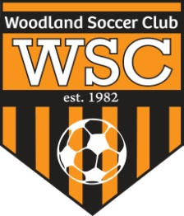

WSC Board Meeting
Wednesday, August 15, 2012

CALL TO ORDER:

Meeting called to order at 5:30pm

ROLL CALL:

APPROVAL OF MINUTES:
Motion to approve made by
Motion passed unanimously.
PRESIDENT REPORT:
- WHS Varsity field is for games only.
- Thanksgiving tournament- U11- 16. Tournament director will be reimbursed.

COMMITTEE REPORT:
- Tino is keeping calendar online of scrimmages. Report seeding games to Tino, Sergio and Jaime
FIRST VICE REPORT:
- Uniforms- Richard will check in Oct for new uniform styles. Will order in December

HEAD COACH REPORT:
- Farhad to meet with Rec teams to help train coaches.
HEAD REFEREE REPORT:
- State Cup- Once teams have negotiated dates, let Sergio know. Fridays are preferable.

TREASURER’S REPORT:
- Finances- Taxes are due in August
REGISTRAR’S REPORT:

SECRETARY’S REPORT:

OLD BUSINESS: None

NEW BUSINESS:
- Ramon OK’d WHS varsity field for scrimmages

GOOD OF GAME:

ADJOURNMENT:
Motion to adjourn by
Meeting adjourned at 7pm

NEXT MEETING:

